# Creating a Jive User Id –

## As an Admin -

1. Create a Student @ ACME General Level with role - NRP Instructor Access (Renewal) course an Student.

Manage Student Features – Turn on NRP related features and manage HealthStream id feature.

Manage Roles -> NRP Instructor Access (Renewal) course with Manage HealthStream Id and NRP Instructor Access(Renewal)course turned ON at both Enterprise and acme gen level.

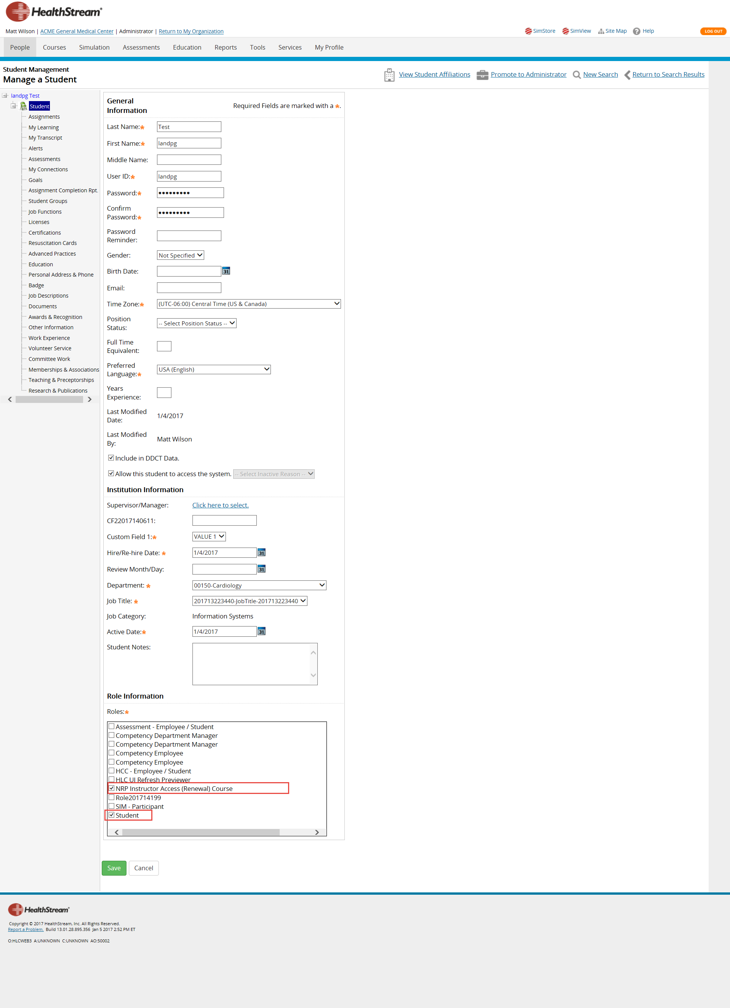

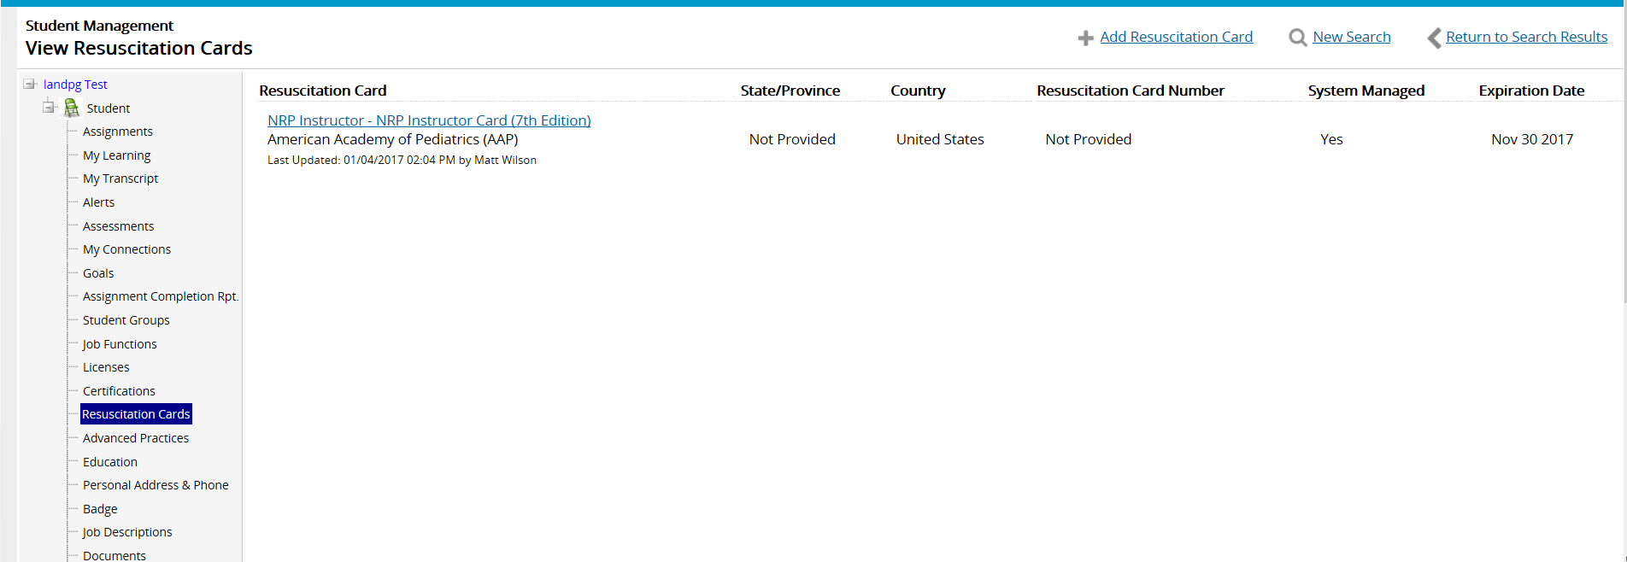

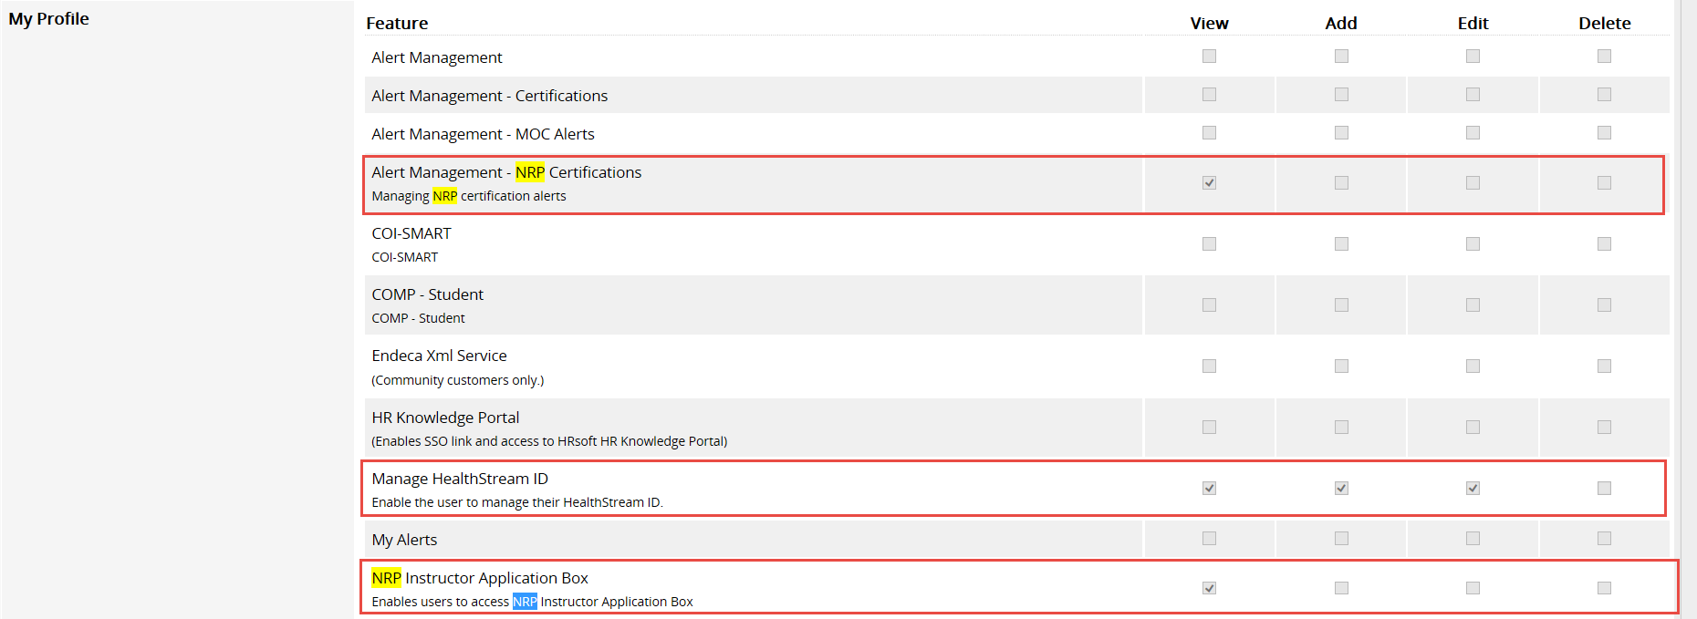

1. Assign Recitation card for that student(expiration date in future)( add both 6th and 7th edition instructor renewal cards.)
2. Create course at HSTM level (Current Edition and NRP Instructor Renewal) with a test and an Attachment toolkit. Add to Equivalent and publish it to downstream.(Publish🡪Advanced Publish🡪ACME Healthcare, select Restrict Course(NRP Instructor Access(Renewal) Course🡪URL: Add new URL )

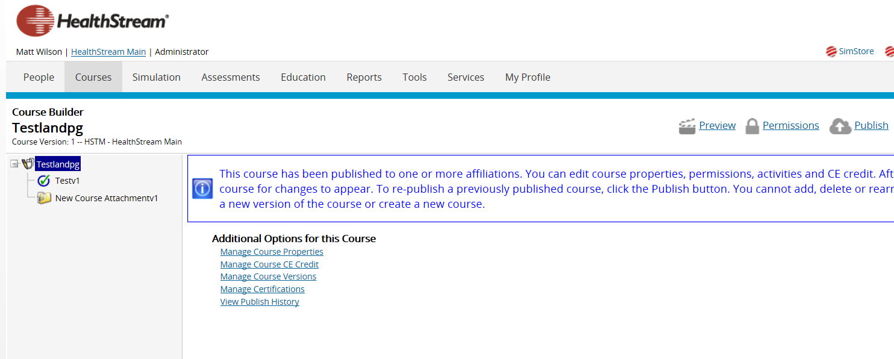

Manage Equivalents –

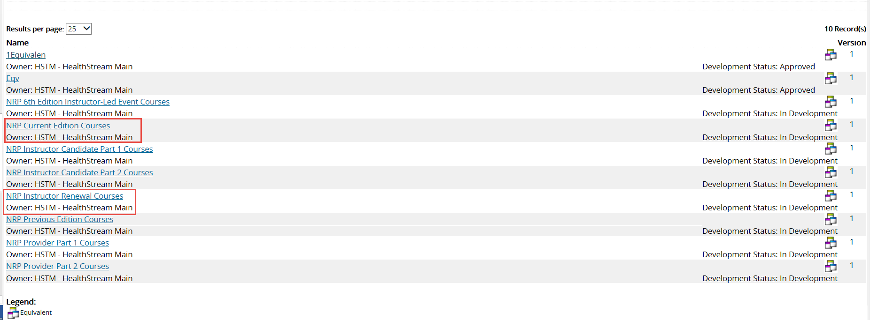

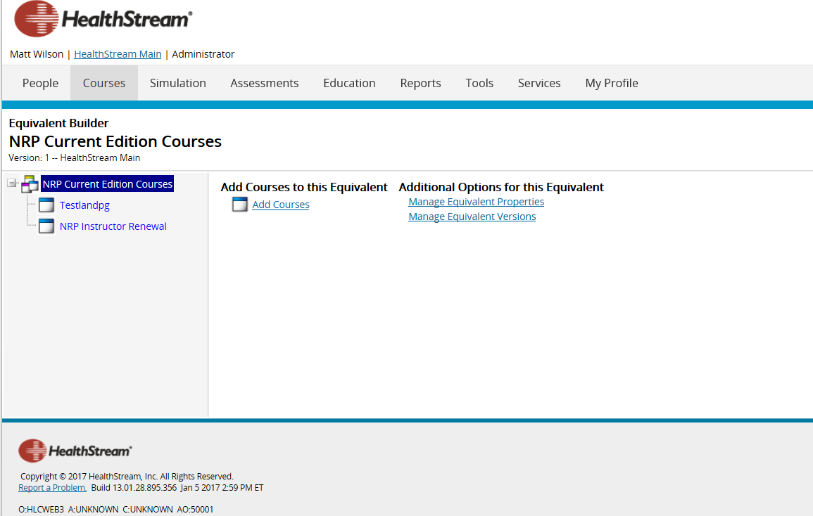

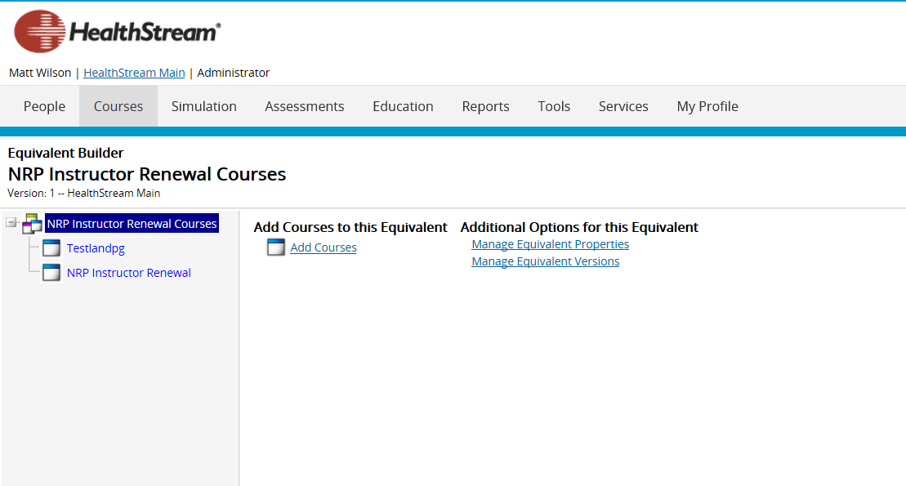

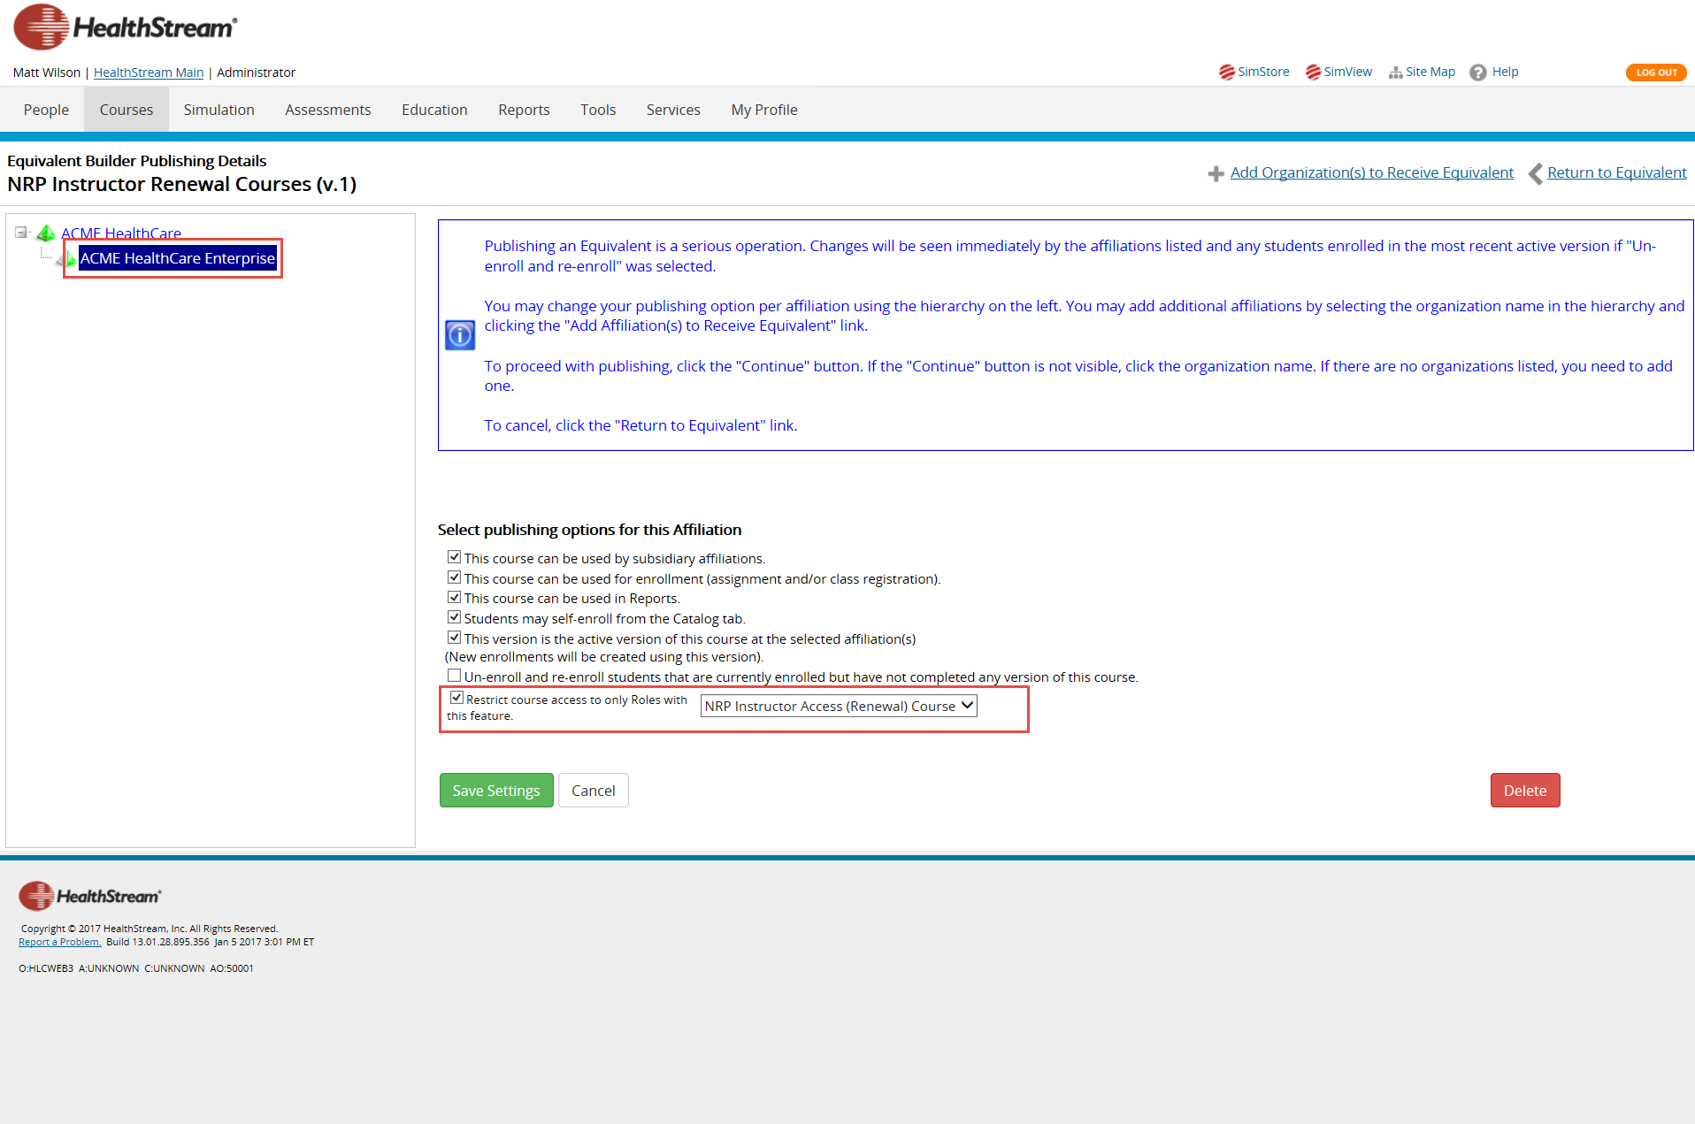

## As a Student -

1. Login as a student
2. Navigate to Profile tab and click on Manage HealthStream ID

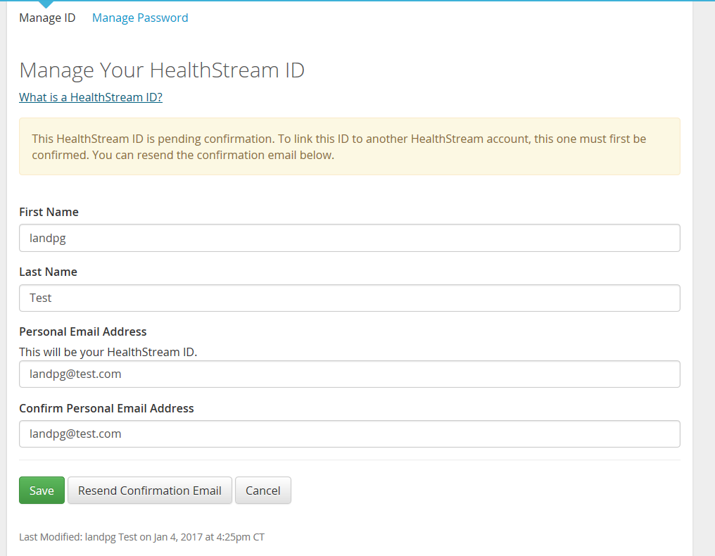

1. Navigate to Catalog and Enroll into the course.

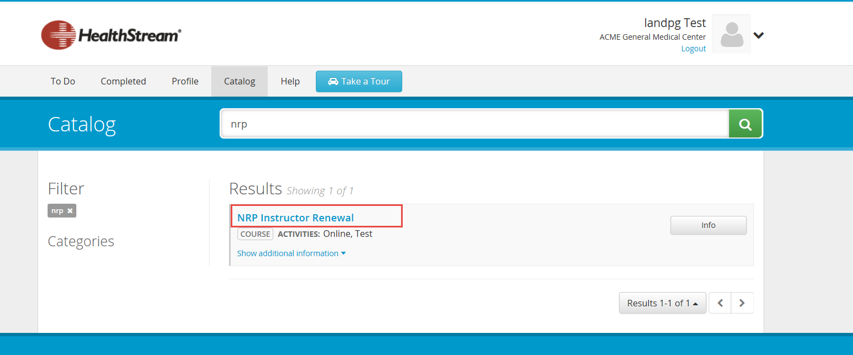

## Jive Page – Add/ Delete Users

Try in Google Chrome after clearing your cookies and temporary files

URL 🡪<https://communities-qa.healthstream.com/>

UID/pwd 🡪mwilson/healthstream

Navigate to Admin Console and to People tab and filter on Created on.

‘X’ mark for delete (to delete from Jive community)

Create/add student to user group –

Jive People tab🡪Members🡪Edit🡪Add member: Search by user id and click on Add.

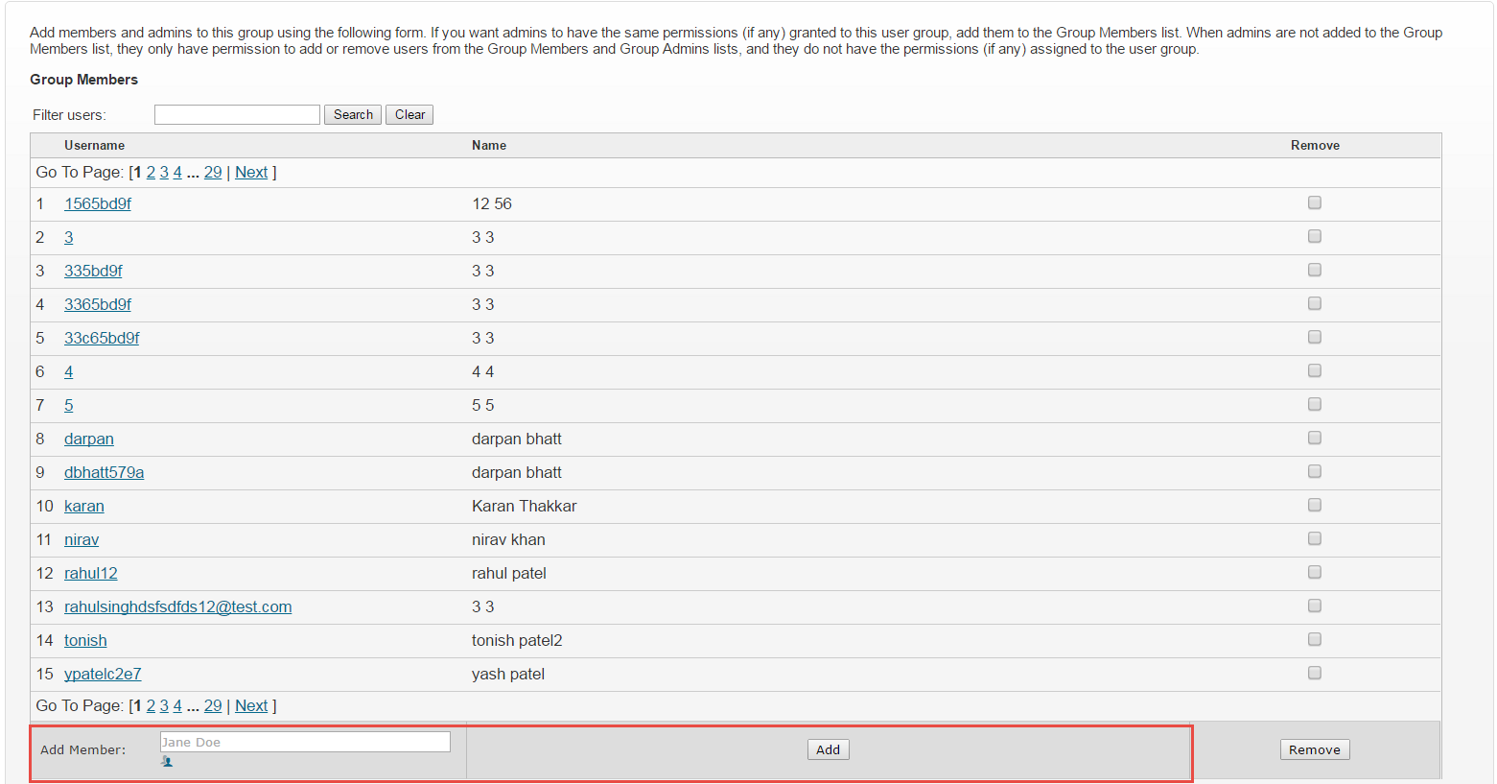

Happy Path for Jive to work -

Log into HLC as student🡪Enroll🡪User created in Jive through API call🡪open SSO link 🡪user logs in successfully! Lands on NRP page.